Lab: Enumerations and Attributes
Part I: Enumerations

- Weekdays
Create Enum Weekday with the days from Monday through Sunday.
Create a class WeeklyCalendar that should have at least the methods:
void AddEntry(string weekday, string notes)
IEnumerable<WeeklyEntry> WeeklySchedule
Create a class WeeklyEntry which should have constructor:
WeeklyEntry(string weekday, string notes)
Implement IComparable<WeeklyEntry> - Entries have to be compare first by their week day and then by note
Override ToString() of WeeklyEntry – "{weekday} - {notes}" (e.g. "Monday - sport", "Sunday - sleep")
Examples
StartUp.cs
WeeklyCalendar calendar = new WeeklyCalendar();
calendar.AddEntry("Monday", "Internal meeting");
calendar.AddEntry("Tuesday", "Create presentation");
calendar.AddEntry("Tuesday", "Create lab and exercise");
calendar.AddEntry("Thursday", "Enum Lecture");
calendar.AddEntry("Monday", "Second internal meeting");

var ordered = calendar.WeeklySchedule.OrderBy(n => n).ToList();
foreach (var weeklyEntry in ordered)
{
Console.WriteLine(weeklyEntry);
}
Hints
Create the WeeklyCalendar:
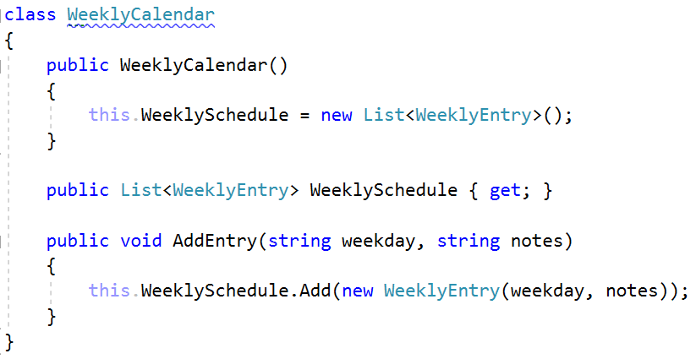

Create WeeklyEntry and think about a solution to compare entries:
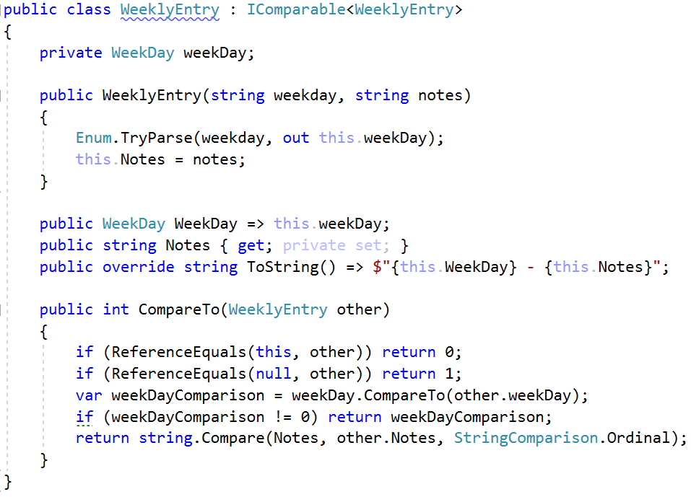

- Coffee Machine
Create a class CoffeeMachine, with methods:
void BuyCoffee(string size, string type)
void InsertCoin(string coin)
IEnumerable<CoffeeType> CoffeesSold { get; }
Create enum CoffeeType - Espresso, Latte, Irish
Create enum Coin - 1, 2, 5, 10, 20, 50 (constants should be named One, Two, Five, etc.)
Create enum CoffeePrice - Small (50 c), Normal (100 c), Double (200 c)
CoffeeMachine should clear all coins after each successful coffee sold.
When you receive "End" command, print all sold coffees.
Examples
StartUp.cs
CoffeeMachine machine = new CoffeeMachine();

string input;
while ((input = Console.ReadLine()) != "End")
{
string[] inputArgs = input.Split();
if (inputArgs.Length == 1)
{
machine.InsertCoin(inputArgs[0]);
}
else
{
machine.BuyCoffee(inputArgs[0], inputArgs[1]);
}
}

foreach (var coffeeType in machine.CoffeesSold)
{
Console.WriteLine(coffeeType);
}

Input | Output
Ten  Twenty  Twenty  Small Espresso  End | Espresso
Ten  Twenty  Small Espresso  Twenty  Small Espresso  End | Espresso  //Comment: first try - not enough coins

Part II: Attributes
- Create Attribute
Create attribute SoftUni with a string element called name, that:
Can be used over classes and methods
Allow multiple attributes of same type
Examples
StartUp.cs
[SoftUni("Ventsi")]
class StartUp
{
[SoftUni("Gosho")]
static void Main(string[] args)
{
}
}
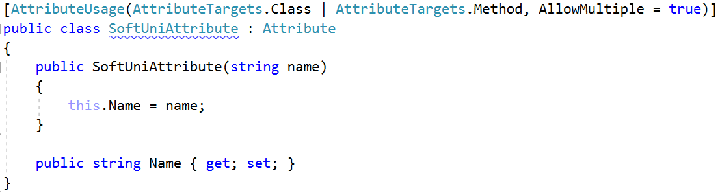
Coding Tracker
Create a class Tracker with a method:
static void printMethodsByAuthor()
Examples
StartUp.cs
[SoftUni("Ventsi")]
class StartUp
{
[SoftUni("Gosho")]
static void Main(string[] args)
{
var tracker = new Tracker();
tracker.PrintMethodsByAuthor();
}
}
